Sri Lanka Institute of Information Technology

B.Sc. (Hons) Information Technology
Cyber security

Building and Securing a DevSecOps Pipeline



IE3142- DevOps Security
Year 3 Semester 1- 2026

Group ID – 64

Table of Contents
2. Executive Summary 4
3. System Overview 4
3.1. Application and technology stack 4
3.2. Architecture and trust boundaries 5
3.3. Containerization and execution 6
4. Threat model and Risk Assessment 6
4.1. Threat Modelling Methodology 6
4.2. Assets 6
4.3. STRIDE Threat Model 7
4.4. Risk Assessment 7
4.5. Detailed Threat Analysis 9
4.5.1. T1 -SQL Injection 9
4.5.2. T2 - Unauthenticated Service Request Access 10
4.5.3. T3 - Server-Side Request Forgery 12
4.5.4. T4 - Broken Object Level Authorization (BOLA/IDOR) 15
4.6. Threat-to-Control Mapping 17
5. Secure Coding Evidence 17
5.1. SQL Injection - Exploit and Fix 17
5.2. Unauthenticated Service Request - Exploit and Fix 19
5.3. SSRF - Exploit and Fix 20
5.4. BOLA/IDOR - Exploit and Fix 22
6. CI/CD Pipeline and Security Automation 23
6.1. Pipeline Overview 23
6.2. Build and Application Validation 24
6.3. SAST - Semgrep 25
6.4. Trivy Dependency / Software Composition Scanning 26
6.5. Secrets Scanning - Gitleaks 27
6.6. Container Image Scanning - Trivy 28
6.7. CI/CD Security Summary 29
7. Secrets Management 30
7.1. Local Development Secrets 30
7.2. GitHub Actions Secrets 30
7.3. Secret Injection 30
8. Industry Trend and Case Study 31
8.1. SolarWinds Supply-Chain Compromise 31
8.2. Lessons Applied to This Project 32
9. Reflection and Future Improvements 32
10. Contributions and AI Use 33
11. Conclusion 33
12. References 34

Executive Summary

This group project applies DevSecOps practices to OWASP crAPI, an intentionally vulnerable API-driven application. The group selected four application-specific weaknesses for assessment: SQL injection in the coupon endpoint, unauthenticated access to a mechanic service request, server-side request forgery (SSRF) through the mechanic API field, and broken object-level authorization (BOLA) in mechanic reports. The group’s baseline notes state that these behaviors were reproduced on an unmodified deployment and describe the data or internal service reached. The repository contains crAPI source, Compose, environment examples, a GitHub Actions workflow, and a Semgrep output reporting nine findings. However, Compose and CI pull published images instead of building the group’s modified source. No fixed-version exploit results or before/after SAST comparison were available for this review. The report separates baseline observations from unverified remediation and CI results. The final technical claim depends on reproducing both versions and retesting each exploit against the fixed build.

Source Code Repository:

https://github.com/Vidumal/DevSecOps-Assignment-

System Overview

Application and technology stack

OWASP crAPI (Completely Ridiculous API) is an intentionally vulnerable training application that simulates a vehicle-owner platform implemented as communicating services. OWASP describes it as a microservice-based application focused on API security risks [3]. The selected project is appropriate to the assignment because it provides multiple interacting services, data stores, and internal endpoints, allowing the group to study authorization, input handling, and trust between services.
The project uses Docker Compose, GitHub Actions, Semgrep, Trivy, and Gitleaks. Compose lists a web frontend, gateway, identity, workshop, community, chatbot, PostgreSQL, MongoDB, ChromaDB, and MailHog. Databases and internal tools should not be public entry points

Architecture and trust boundaries
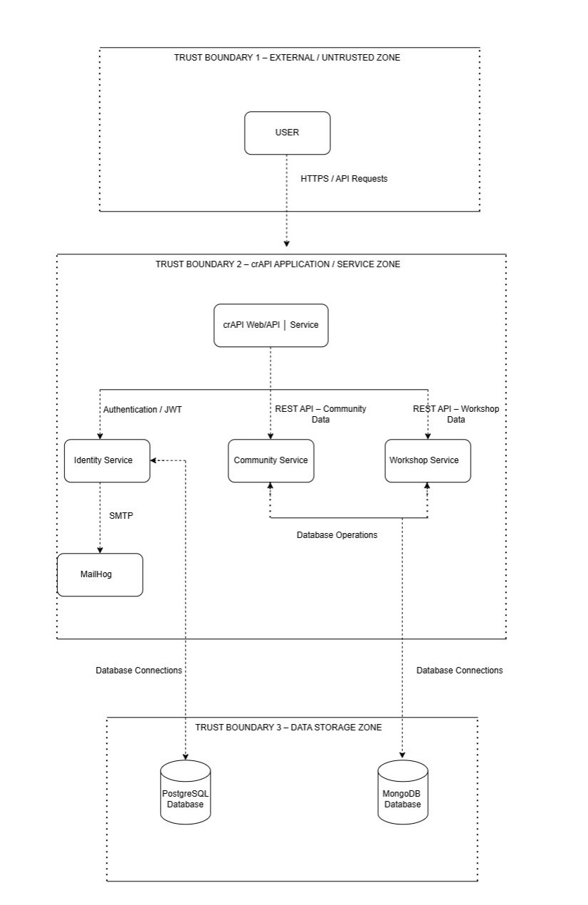

STRIDE diagram
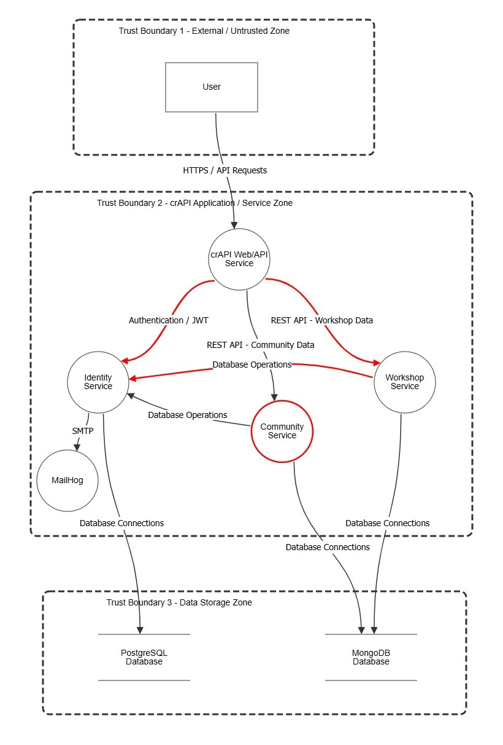

Containerization and execution
The root Compose file uses published images, while crAPI/ contains source. This starts upstream crAPI but does not prove changed code is running. Connect the affected service Dockerfiles/build contexts to Compose and label baseline and fixed images separately. Document prerequisites, startup/shutdown, URLs, and the version selection in README; verify a clean checkout.

Threat model and Risk Assessment

Threat Modelling Methodology

The crAPI application was threat-modelled using the STRIDE methodology. The objective was to identify threats affecting authentication, authorization, application data, backend services and communication between microservices.
The assessment focused on four vulnerabilities identified during testing of the unmodified crAPI deployment:
- SQL Injection
- Unauthenticated Service Request Access
- Server-Side Request Forgery
- Broken Object Level Authorization
The threats were selected because they are directly applicable to the application's API architecture and can result in unauthorized data access, unauthorized functionality, manipulation of application data, or access to internal services.

Assets
The main assets identified in the crAPI environment are:
Asset | Description
User accounts | Authentication credentials and user identity information
Vehicle information | VIN, vehicle details, ownership information and vehicle-related data
Service requests | Mechanic requests, problem descriptions and customer information
Database records | PostgreSQL/MongoDB application data
Internal services | Workshop, identity and other Docker services
Internal network | Docker network containing backend services
API endpoints | Interfaces through which users interact with application functionality
Application secrets | Database credentials, API secrets and service credentials

STRIDE Threat Model
ID | STRIDE Category | Threat | Related Vulnerability | Affected Component
T1 | Tampering / Information Disclosure | Attacker manipulates database query input to retrieve unintended database information | SQL Injection | Workshop API / Database
T2 | Spoofing / Elevation of Privilege | Unauthenticated user accesses service-request information | Unauthenticated Service Request Access | Workshop API
T3 | Server-Side Request Forgery / Information Disclosure | Attacker causes backend server to make requests to internal services | SSRF | Workshop API / Internal network
T4 | Elevation of Privilege / Information Disclosure | Authenticated user accesses another user's service-request object | BOLA/IDOR | Mechanic report API

The SQL injection evidence shows that the apply_coupon endpoint accepted SQL-related input and returned database information, demonstrating the potential for database-level impact.
The unauthenticated service-request test demonstrated that GET /workshop/api/mechanic/service_request/1 returned 200 OK without authentication and exposed mechanic and vehicle-owner information.
The SSRF test demonstrated that the attacker-controlled mechanic_api field could be used to reach the internal MailHog service, with the internal service response returned through the API.
The BOLA test demonstrated that an authenticated user could access report ID 1 belonging to another user, with vehicle VIN, email, mobile number and problem details exposed.

Risk Assessment
Likelihood
Score | Description
1 | Rare
2 | Unlikely
3 | Possible
4 | Likely
5 | Almost Certain

Impact
Score | Description
1 | Negligible
2 | Minor
3 | Moderate
4 | Major
5 | Severe

Risk Score = Likelihood × Impact
Threat | Likelihood | Impact | Risk Score | Risk Level | Reason
T1 – SQL Injection | 4 | 5 | 20 | Critical | Database query manipulation can expose or modify application data
T2 – Unauthenticated Service Request Access | 4 | 4 | 16 | High | Service-request and vehicle-owner information can be accessed without authentication
T3 – SSRF | 4 | 5 | 20 | Critical | Backend can be induced to access internal services
T4 – BOLA/IDOR | 4 | 4 | 16 | High | Authenticated users can access another user's service-request information

Detailed Threat Analysis

T1 -SQL Injection

Vulnerability
The affected endpoint is:
POST /workshop/api/shop/apply_coupon
The evidence document records the SQL-injection payload and states that the response exposed the value 9876540001. The documented root cause is direct concatenation of user input into SQL.

Threat
An attacker can provide crafted input that changes the intended SQL statement.

Impact
Potential consequences include:
- Unauthorized database information disclosure
- Modification of database records
- Authentication-related data exposure
- Potential broader database compromise depending on database privileges

Recommended control
Use parameterized queries/prepared statements rather than constructing SQL statements through string concatenation.
Conceptually:
Unsafe:

"SELECT ... WHERE coupon = '" + userInput + "'"

Secure:

"SELECT ... WHERE coupon = ?"

Exploit code we used:
await probe("SQL injection baseline", "/workshop/api/shop/apply_coupon", {
method: "POST",
credentials: "omit",
headers: {
"Content-Type": "application/json",
"Authorization": `Bearer ${JWT}`
},
body: JSON.stringify({
coupon_code: "'; SELECT number FROM user_login WHERE email='test@example.com",
amount: 75
})
});

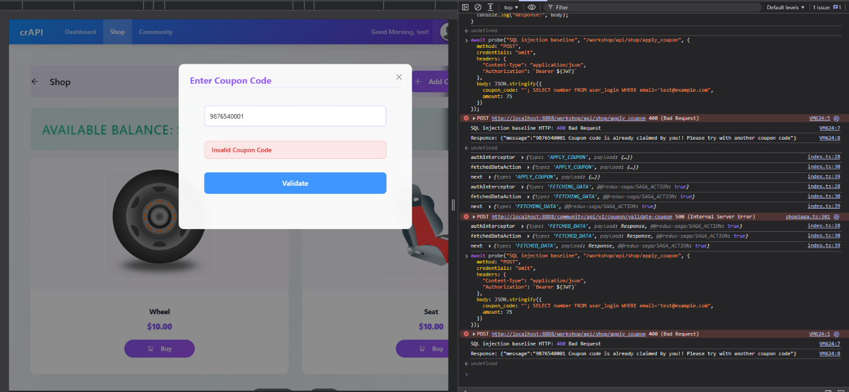

T2 - Unauthenticated Service Request Access
Vulnerability
Affected endpoint:
GET /workshop/api/mechanic/service_request/1
The evidence identifies no authentication and records a 200 OK response containing mechanic and vehicle-owner information.
Threat
An unauthenticated attacker can directly request a service-request object without first proving their identity.
Impact
Potential exposure includes:
- Vehicle information
- Customer information
- Mechanic information
- Service-request information
Recommended control
The endpoint should require authentication before processing the request.
A suitable flow is:
Request
↓
Authentication middleware
↓
Valid token?
┌─┴─┐
No Yes
↓ ↓
401 Authorization check
The endpoint should reject unauthenticated requests with an appropriate 401 Unauthorized response.

Exploit code we used:
await probe("Unauthenticated service request", "/workshop/api/mechanic/service_request/1", {
method: "GET",
credentials: "omit",
headers: { "Accept": "application/json" }
});

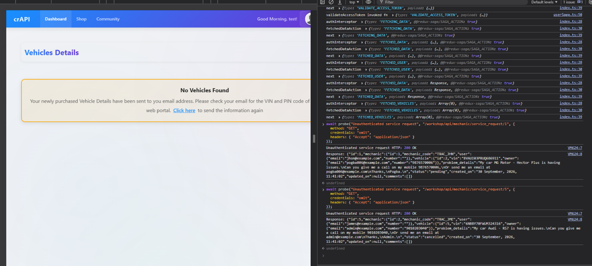

T3 - Server-Side Request Forgery
Vulnerability
Affected endpoint:
POST /workshop/api/merchant/contact_mechanic
The attacker-controlled field is:
mechanic_api
The evidence demonstrates that supplying:
http://mailhog:8025
caused the backend to reach the internal MailHog service and return its HTML response.
Threat
The attacker does not directly access the internal service. Instead:
Attacker
↓
crAPI API
↓
Backend server
↓
Internal service
The backend becomes the attacker's HTTP client.
Impact
Depending on network configuration and available internal services, SSRF can potentially allow:
- Internal service discovery
- Access to internal administrative interfaces
- Access to cloud metadata services in cloud deployments
- Internal network reconnaissance
- Retrieval of sensitive internal responses
Recommended control
Do not allow arbitrary URLs supplied by users.
Use:
- URL allowlisting
- Strict hostname validation
- IP address validation
- Blocking private/internal address ranges
- Blocking loopback addresses
- Blocking link-local addresses
- Restricting outbound network access
For this project, the strongest implementation is to avoid accepting arbitrary mechanic_api URLs and instead map approved mechanic services to predefined server-side destinations.
Exploit code we used:

(async () => {
const token = prompt("Paste your local crAPI test-account JWT");
if (!token) {
console.log("No token entered; request cancelled.");
return;
}

const response = await fetch(
"http://localhost:8888/workshop/api/merchant/contact_mechanic",
{
method: "POST",
credentials: "omit",
headers: {
"Content-Type": "application/json",
"Authorization": `Bearer ${token}`
},
body: JSON.stringify({
mechanic_api: "http://mailhog:8025",
mechanic_code: "TRAC_JHN",
problem_details: "Local assignment SSRF test",
vin: "9NFXO86WBWA082766",
repeat_request_if_failed: false,
number_of_repeats: 1
})
}
);

console.log("HTTP:", response.status, response.statusText);
console.log("Response:", await response.text());
})();

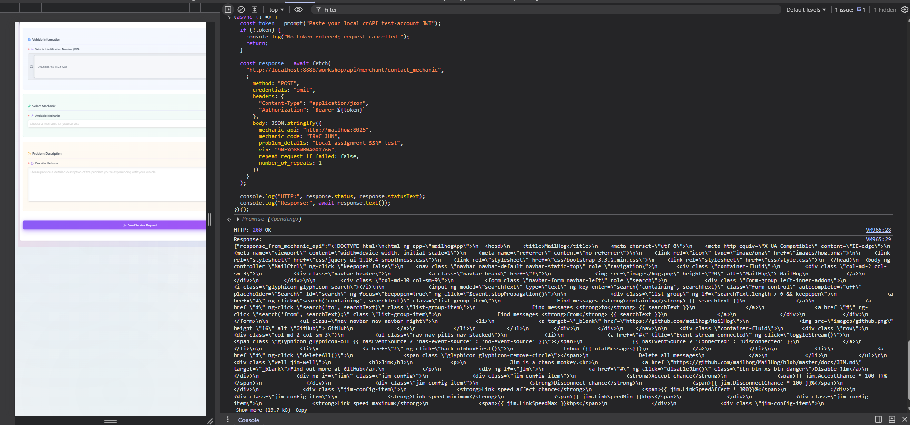

T4 - Broken Object Level Authorization (BOLA/IDOR)

Vulnerability
Affected endpoint:
GET /workshop/api/mechanic/mechanic_report?report_id=1
The evidence shows that authenticated user test@example.com accessed report ID 1, while the actual object owner was adam007@example.com. The response exposed vehicle VIN, email, mobile number and problem details.
Threat
The server uses a client-controlled object identifier without verifying that the authenticated user owns or is authorized to access the requested object.
Conceptually:
User B
|
| report_id=1
↓
API
|
| "Does report 1 belong to User B?"
|
X No ownership check
|
↓
User A's report

Recommended control
Perform a server-side ownership/authorization check:
Authenticated user
↓
Requested report
↓
Does report.owner_id == user.id?
↓
┌───┴────┐
Yes No
↓ ↓
Return 403
data Forbidden
The authorization decision must occur on the server and must never rely solely on the object ID supplied by the client.

Exploit code we used:

(async () => {
const token = prompt("Paste your local crAPI test-account JWT");
if (!token) {
console.log("No token entered; request cancelled.");
return;
}

const response = await fetch(
"http://localhost:8888/workshop/api/mechanic/mechanic_report?report_id=1",
{
method: "GET",
credentials: "omit",
headers: {
"Accept": "application/json",
"Authorization": `Bearer ${token}`
}
}
);

console.log("HTTP:", response.status, response.statusText);
console.log("Response:", await response.text());
})();

Threat-to-Control Mapping

Threat | Vulnerability | Primary Control | Expected Result
T1 | SQL Injection | Parameterized queries / prepared statements | User input cannot alter SQL structure
T2 | Unauthenticated Service Request | Authentication middleware | Unauthenticated requests receive 401
T3 | SSRF | URL allowlisting + private IP blocking + outbound restrictions | Arbitrary internal destinations cannot be reached
T4 | BOLA/IDOR | Object-level authorization / ownership validation | Users cannot access another user's objects

Secure Coding Evidence
This section should document the exploit → code fix → same exploit re-tested workflow.

SQL Injection - Exploit and Fix

Test | Before Fix | After Fix
Payload | '; SELECT number FROM user_login WHERE email='test@example.com | Same exact payload
Status | HTTP 400 | HTTP 400
Result | Exposed 9876540001 | Coupon not found
SQL injection executed | Yes | No evidence of execution
Sensitive data exposed | Yes | No

Security Fix:
The query was changed to use parameterized database access. User-controlled input is passed as a parameter rather than concatenated into the SQL statement.
Retest:
The exact baseline payload was submitted against the rebuilt application. The request was rejected as an invalid coupon and no database value was returned. This demonstrated that the original SQL injection condition was no longer reproducible.
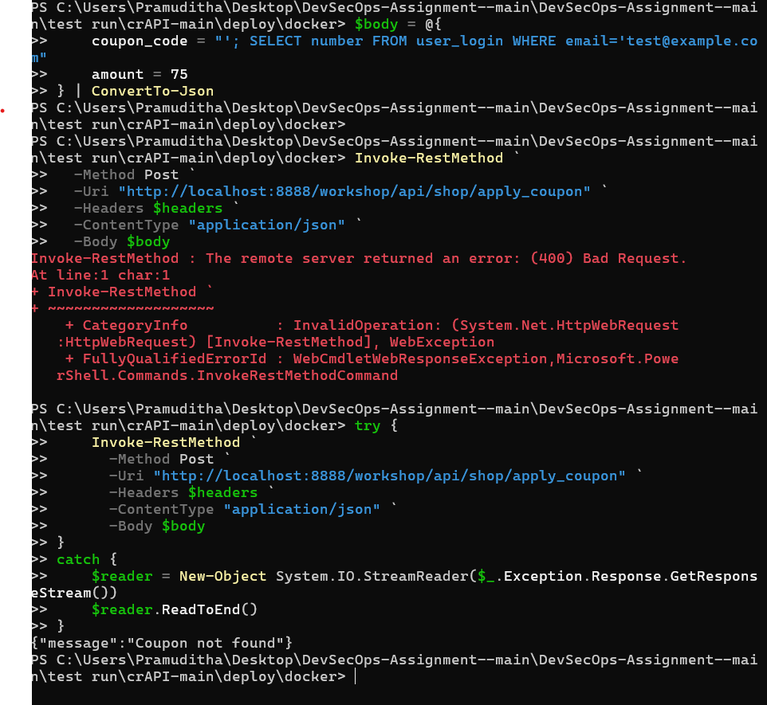
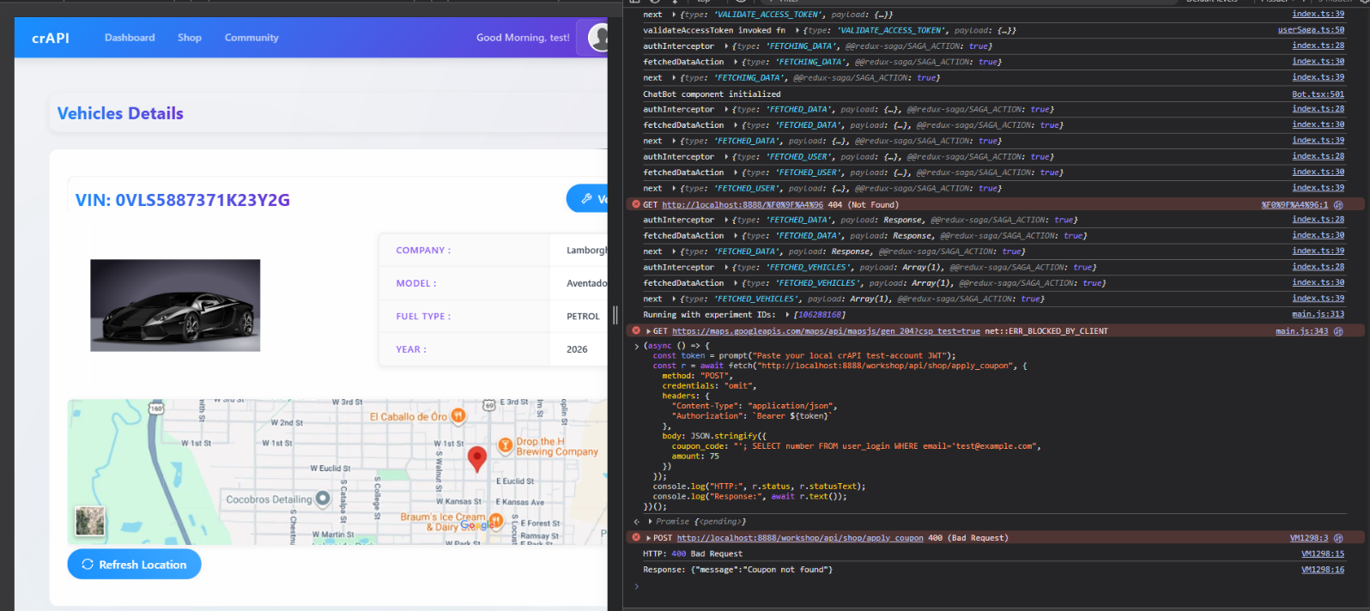

Unauthenticated Service Request - Exploit and Fix
Test | Before Fix | After Fix
Endpoint | GET /workshop/api/mechanic/mechanic_report?report_id=1 | Same
Authenticated user | test@example.com | Same
report_id | 1 | 1
Result | 200 OK + another user's report | Report does not exist
Other user's data exposed | Yes | No

Root Cause:
The endpoint did not enforce authentication before processing the service-request lookup. As a result, possession of the endpoint URL was sufficient to retrieve the object.
Security Fix:
Authentication enforcement was added so that the endpoint requires a valid authenticated user before processing the request.
Retest:
The same unauthenticated request was sent against the rebuilt application. The server rejected the request with HTTP 401 Unauthorized and did not return the service-request data.
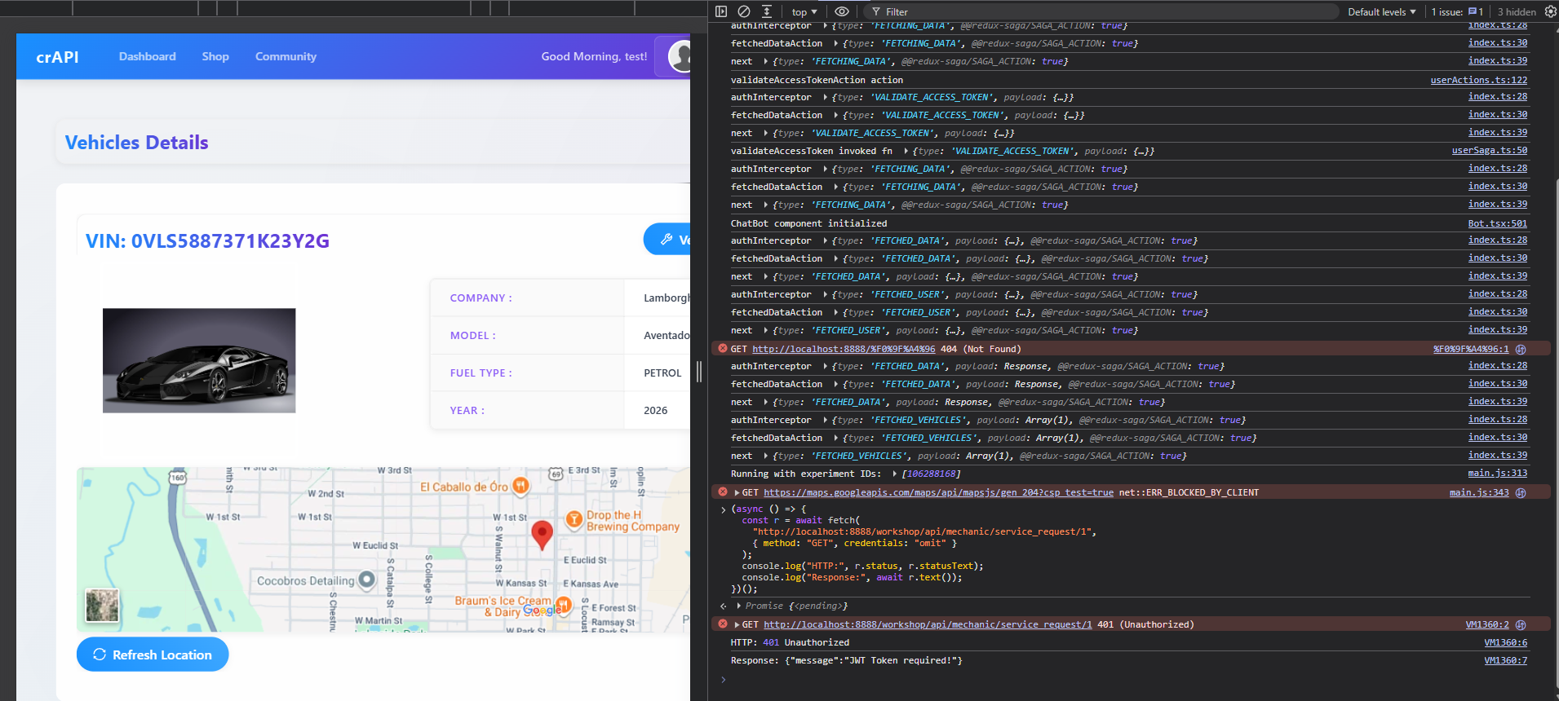

SSRF - Exploit and Fix

Item | Result
Vulnerability | SSRF
Endpoint | POST /workshop/api/merchant/contact_mechanic
Original payload | http://mailhog:8025
Original result | MailHog internal HTML returned
Fix | Validate/deny unsafe destination URLs
Same payload after fix | Rejected
HTTP result | 400 Bad Request
Status | Fixed & verified

Root Cause:
The endpoint accepted a user-controlled URL and used it as a backend destination without sufficiently restricting the destination. Because the backend container can communicate with internal Docker services, an attacker could use the API as a proxy to reach an internal service.
Security Fix:
The implementation was changed to reject arbitrary destinations and enforce destination validation. Requests to internal, loopback, link-local and private network destinations are rejected. Where possible, approved mechanic destinations are represented by predefined server-side values rather than accepting arbitrary URLs from the client.
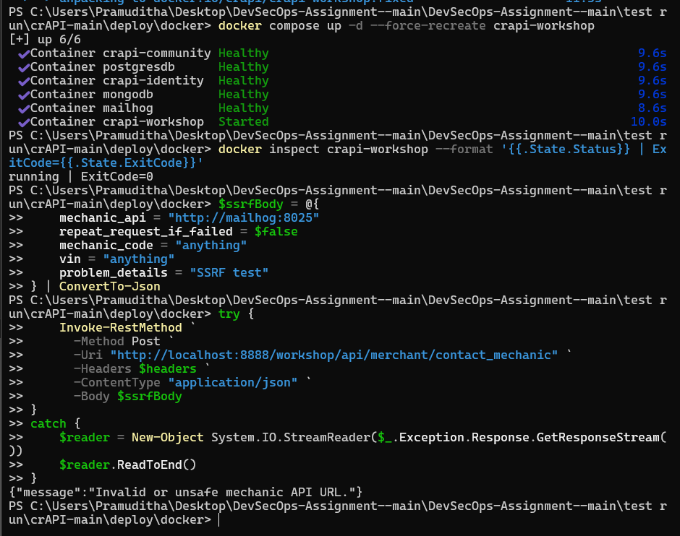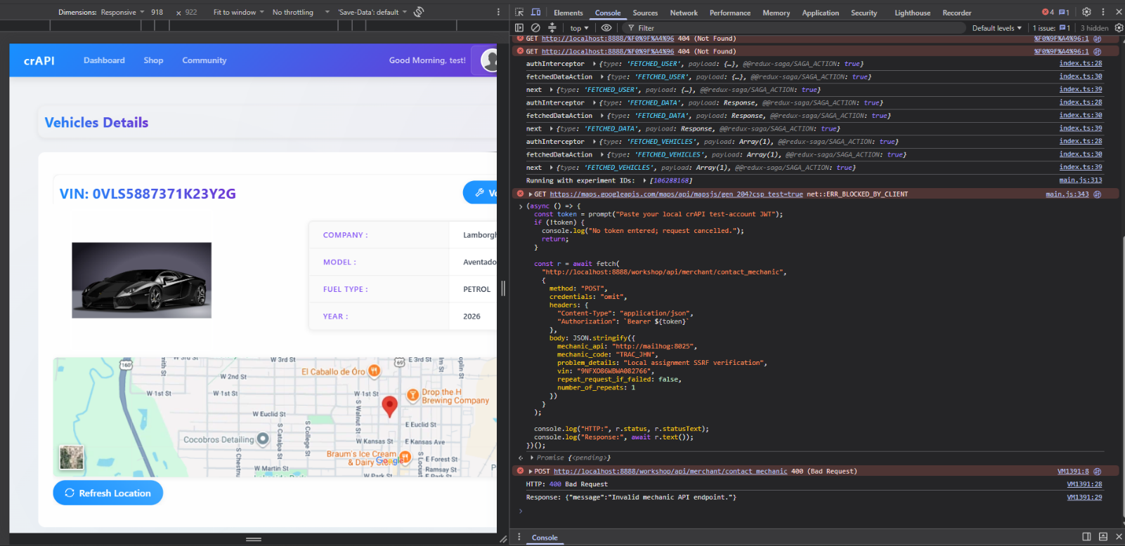

BOLA/IDOR - Exploit and Fix
Item | Details
Vulnerability | Broken Object Level Authorization (BOLA / IDOR)
Affected Endpoint | GET /workshop/api/mechanic/mechanic_report?report_id=1
Before Exploitation | An authenticated user could request another user's service report by changing/providing the report_id. The original code retrieved the service request using only the supplied ID, without verifying that it belonged to the authenticated mechanic.
Exploit | Logged in as test@example.com and requested report_id=1, which belonged to another user (adam007@example.com).
Evidence Before Fix | HTTP 200 OK returned the other user's report, including VIN, email, phone number, vehicle information and problem details.
Impact | Unauthorized users could access service-request information belonging to other users, causing sensitive personal and vehicle information disclosure.
Security Fix | The query was changed to verify both the requested ID and the authenticated mechanic: ServiceRequest.objects.filter(id=report_id, mechanic__user=user).first()
After Exploitation | The exact same request returned 404 Not Found with {"message":"The Report does not exist for given report_id."} instead of the other user's report.

CI/CD Pipeline and Security Automation

Pipeline Overview
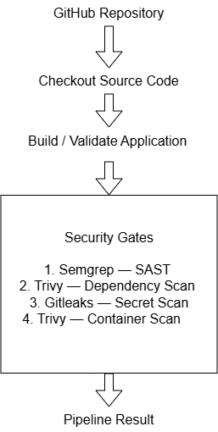
A GitHub Actions-based CI/CD security pipeline was implemented to automate application validation and security checks for the crAPI application. The pipeline is triggered automatically when changes are pushed to the main or develop branches and when pull requests are opened against the main branch. A workflow_dispatch trigger is also provided to allow the pipeline to be executed manually when required.
The pipeline performs source-code checkout, application validation, and multiple automated security checks. Four security controls were integrated into the workflow: Semgrep for Static Application Security Testing (SAST), Trivy for dependency vulnerability scanning, Gitleaks for secret detection, and Trivy for Docker container image scanning.

The overall pipeline can be represented as follows:

The workflow is configured to run on:
- Push to main
- Push to develop
- Pull request to main
- Manual execution using workflow_dispatch
The use of automated security gates allows security checks to be performed consistently whenever source-code changes are introduced rather than relying only on manual security testing.

Build and Application Validation
The pipeline begins by checking out the source code from the GitHub repository using GitHub Actions. Docker Compose is then validated to ensure that the application's Compose configuration is syntactically valid before security scanning is performed.
The repository contains the crAPI service source code and Dockerfiles. In particular, the workshop service containing the selected application vulnerabilities has its own Dockerfile located at:
crAPI/services/workshop/Dockerfile
The workshop Dockerfile uses Python 3.11 and packages the workshop service into a Docker image.
During the initial implementation, the Compose configuration referenced the published image:
crapi/crapi-workshop:latest
and the pipeline used:
docker compose pull
This approach downloads the upstream crAPI image and therefore does not guarantee that the Docker image being scanned contains modifications made to the application's source code.
For the final DevSecOps implementation, the affected service is required to be built from the checked-out repository source before the resulting image is passed to the container security scanner. This ensures that the security pipeline evaluates the same application version that has been modified and tested by the group
This approach downloads the upstream crAPI image and therefore does not guarantee that the Docker image being scanned contains modifications made to the application's source code.
For the final DevSecOps implementation, the affected service is required to be built from the checked-out repository source before the resulting image is passed to the container security scanner. This ensures that the security pipeline evaluates the same application version that has been modified and tested by the group.

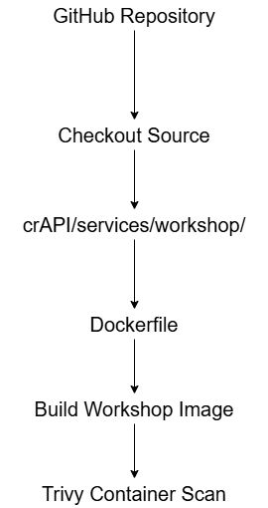

SAST - Semgrep
Tool and Purpose
Semgrep was integrated into the pipeline to perform Static Application Security Testing (SAST). SAST examines the application source code for insecure coding patterns without requiring the application to be executed.
The workflow uses the Semgrep security-audit ruleset:
- name: Run Semgrep
uses: semgrep/semgrep-action@v1
with:
config: p/security-audit

The purpose of this gate is to identify security weaknesses directly in the source code and prevent code containing blocking security findings from progressing through the pipeline.
Baseline Result
During the initial pipeline execution, Semgrep scanned 1,139 tracked files using 225 code rules and identified 9 blocking findings. The findings included:
- Flask application configured to listen on an insecure host configuration
- Use of math/rand instead of a cryptographically secure random generator
- Spring Security CSRF protection disabled
- Insecure hostname verification
- Disabled TLS certificate verification using verify=False
- Django @csrf_exempt usage
- Other disabled certificate-validation controls
The Semgrep workflow completed its scan successfully, but because blocking findings were detected, it returned exit code 1. Therefore, GitHub Actions marked the security job as failed.
The important distinction is that the scanner itself did not crash. The non-zero exit code represents the intended security-gate behaviour.

Trivy Dependency / Software Composition Scanning
Trivy filesystem scanning was integrated to identify known vulnerabilities in third-party application dependencies.
The relevant configuration is:
scan-type: fs
scan-ref: .
scanners: vuln
severity: HIGH,CRITICAL
ignore-unfixed: true
exit-code: '1'

The filesystem scan examines dependency manifests contained in the repository, including Python requirements files, Go module files and the web application's npm package-lock file.
The severity threshold was configured to identify HIGH and CRITICAL vulnerabilities. The ignore-unfixed option prevents vulnerabilities without an available fix from being treated as actionable by this particular gate.

Baseline Result
The initial scan identified 127 vulnerabilities across the dependency files scanned by Trivy.
The reported vulnerabilities were distributed across:
Dependency source | Vulnerabilities
chatbot/requirements.txt | 13
community/go.mod | 19
gateway-service/go.mod | 0
web/package-lock.json | 78
workshop/requirements.txt | 17
Total | 127

Secrets Scanning - Gitleaks
Gitleaks was integrated into the pipeline to detect accidentally committed credentials, API keys, passwords and other sensitive information.
The workflow uses:
- name: Checkout repository
uses: actions/checkout@v6
with:
fetch-depth: 0

The complete Git history is made available to the scanner so that committed secrets can be detected rather than scanning only the latest working tree.
The Gitleaks action is then executed using the repository's GitHub Actions token:
- name: Run Gitleaks
uses: gitleaks/gitleaks-action@v3
env:
GITHUB_TOKEN: ${{ secrets.GITHUB_TOKEN }}

The complete Git history is made available to the scanner so that committed secrets can be detected rather than scanning only the latest working tree.
The Gitleaks action is then executed using the repository's GitHub Actions token:
- name: Run Gitleaks
uses: gitleaks/gitleaks-action@v3
env:
GITHUB_TOKEN: ${{ secrets.GITHUB_TOKEN }}

Baseline Result
The initial Gitleaks scan completed successfully. The scan reported:
1 commits scanned
no leaks found
No leaks detected

Container Image Scanning - Trivy
Trivy was also integrated as a container image security scanner. Unlike the filesystem scan, this gate examines the Docker image itself and can identify vulnerabilities in both operating-system packages and application libraries contained inside the image.
The configured scan checks:
scan-type: image
vuln-type: os,library
severity: HIGH,CRITICAL
ignore-unfixed: true
exit-code: '1'

The initial implementation pulled the upstream crAPI workshop image:

crapi/crapi-workshop:latest
and scanned that image.
However, this approach does not guarantee that the image contains the group's source-code modifications. Therefore, the final implementation must build the workshop image from:
crAPI/services/workshop/Dockerfile

and scan that locally built image.
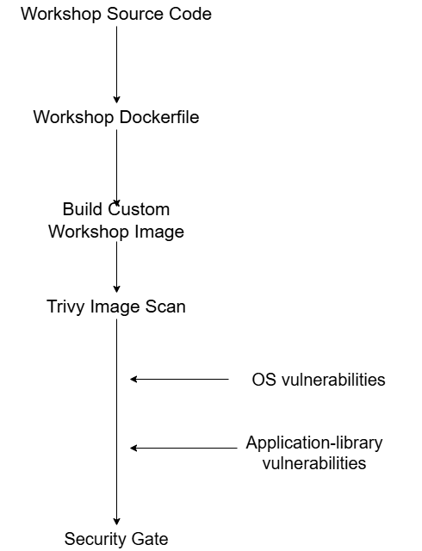
The intended final flow is:

CI/CD Security Summary
The implemented pipeline integrates security checks into the software delivery process rather than treating security testing as a separate manual activity. Semgrep provides static source-code analysis, Trivy performs dependency and container vulnerability scanning, and Gitleaks checks for accidentally committed secrets.
The initial pipeline execution successfully demonstrated the operation of the security gates. Semgrep identified nine blocking source-code findings, while the Trivy filesystem scan identified 127 dependency vulnerabilities. Gitleaks completed successfully without detecting secrets.
The final pipeline implementation extends this approach by building the affected workshop service from the repository source and scanning the resulting Docker image. This ensures that the container security gate evaluates the same application version that has been modified and tested by the project team.
The final evidence will therefore demonstrate the complete DevSecOps feedback loop:

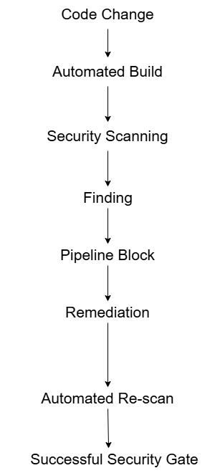

Secrets Management
The repository includes an .env.example containing placeholder values for database users/passwords and application secrets. Its .gitignore excludes .env and common private-key formats. This is a sound starting convention, but the available files do not demonstrate how GitHub Actions secrets are provisioned to a deployment or how the running application receives production-like secrets. The final report should state that example values are not credentials, confirm that a real .env file is untracked, and describe the actual secret-injection mechanism used. At minimum, CI credentials must use encrypted GitHub Actions secrets or short-lived built-in tokens, and runtime secrets should be supplied outside source control. Do not include actual values in the report, screenshots, logs, or repository. Review current tracked files and presented history for accidental credentials; rotate any real credential that was committed.

Local Development Secrets
Development secrets are stored outside the tracked source code using a local .env file. The .env file is excluded from Git tracking using .gitignore, while .env.example contains only placeholder values required to explain the configuration structure.
No real passwords, API keys or private credentials are included in the repository or report.

GitHub Actions Secrets
Secrets required by CI/CD are configured using GitHub Actions encrypted repository secrets. Secret names are referenced by the workflow without exposing their values in source code.
Examples include database passwords, application secrets and service credentials. The actual values are not stored in the repository and are not displayed in screenshots or CI logs.

Secret Injection
During CI execution, secrets are supplied to the workflow through GitHub's encrypted secret mechanism. The workflow references the secret using the GitHub Actions expression syntax and passes it only to the step requiring it.
This separates secret material from application source code and reduces the risk of accidental disclosure through version control.

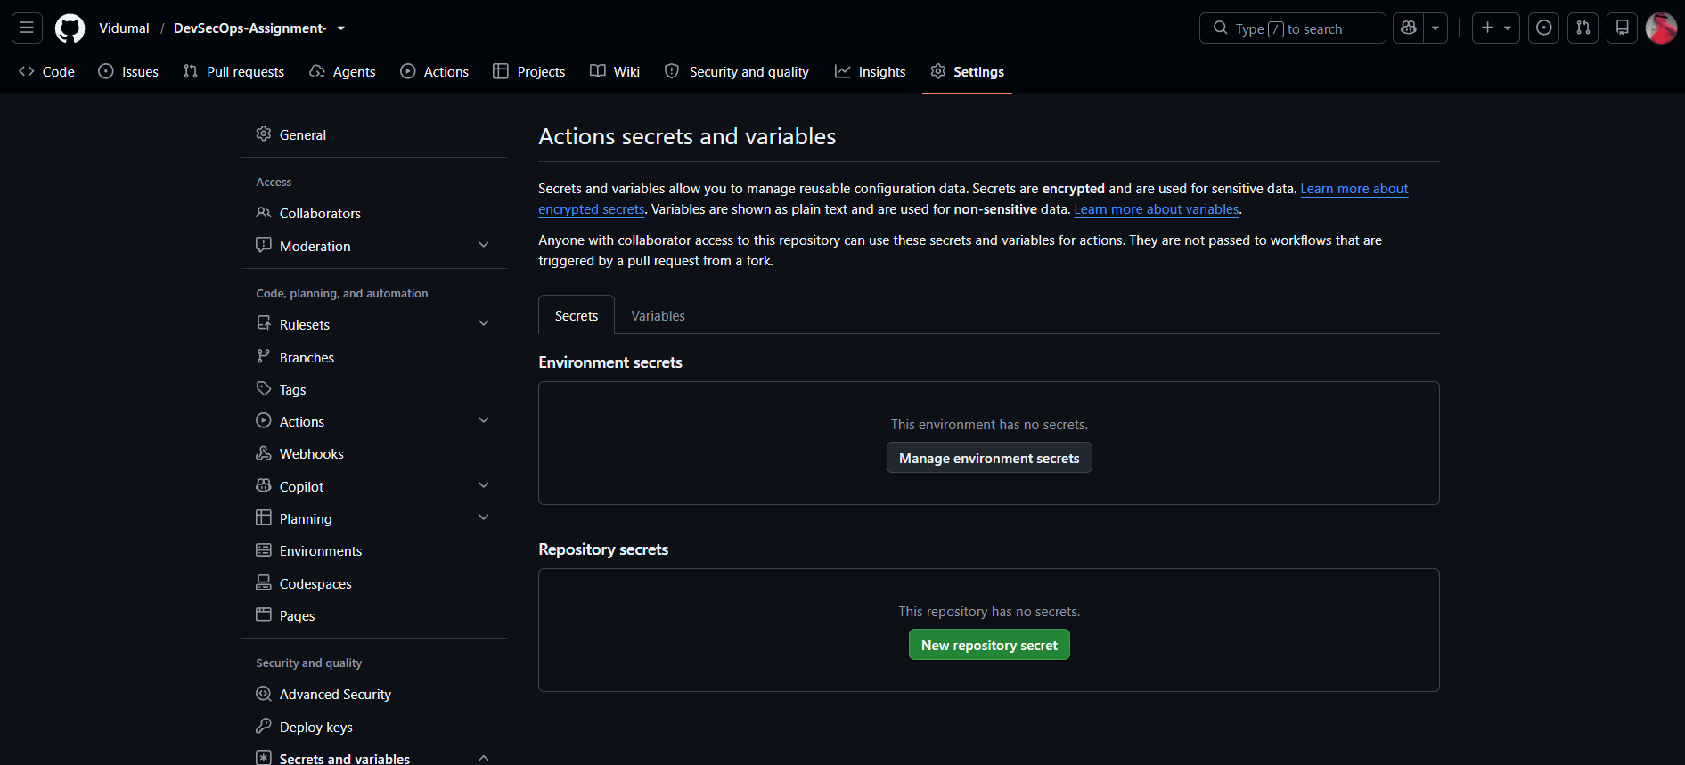

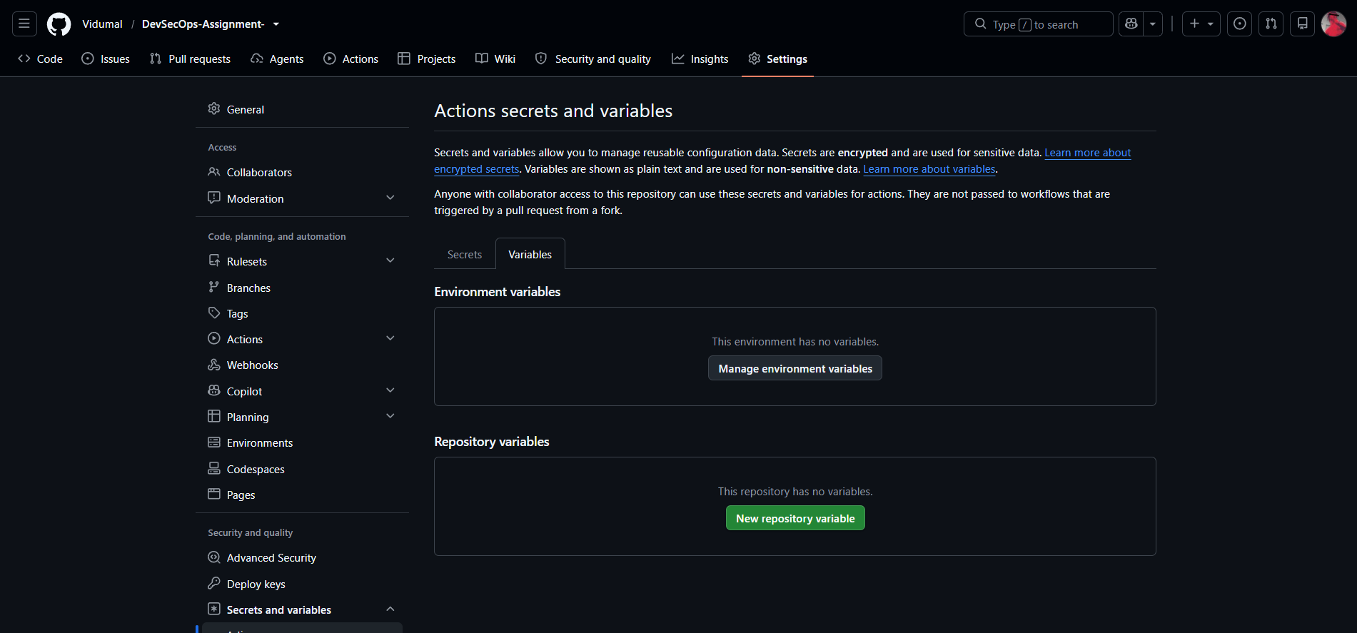

Industry Trend and Case Study

SolarWinds Supply-Chain Compromise
The SolarWinds Orion supply-chain compromise illustrates why security must cover the build and distribution path as well as application code. CISA’s Alert AA20-352A described compromises affecting government, critical infrastructure, and private-sector organizations and identified the Orion software supply chain as one initial access vector [1]. The relevant lesson for this project is that a security scan of source code alone cannot prove that the deployed artifact corresponds to reviewed source or that its dependencies and build path are trustworthy. The project maps this lesson to source, dependency, secret, and image checks. Those gates only protect delivery when they examine the artifact built from the reviewed commit. Pin inputs, protect branches, tag builds reproducibly, and demonstrate a failing threshold. The current Compose-pull workflow leaves a gap: an upstream image scan does not validate the group’s modified source [2].

Lessons Applied to This Project
SolarWinds lesson | Project control
Source integrity | Git repository + review
Dependency risk | Trivy filesystem scan
Secret exposure | Gitleaks
Artifact integrity | Build image from repository source
Container vulnerabilities | Trivy image scan
Automated enforcement | GitHub Actions security gates

Reflection and Future Improvements
The project showed that selecting vulnerabilities is only the start. Each remediation needs a reproducible baseline, a reviewable code change, and a retest under the same conditions. Authorization tests need identities for both unauthorized and legitimate access. SSRF testing also highlights why the Docker network boundary must be explicit: the backend can reach a service that an external caller cannot.

With more time, the group would add automated regression tests for each security correction, generate a software bill of materials, pin container base images by digest, produce build provenance, and restrict egress from services that do not need outbound access. It would add least-privilege database accounts, centralize structured security logs, and use a dedicated secret manager for runtime deployment. The current workflow should also separate source and image scanning clearly and publish a compact security summary as a CI artifact. These are proposed improvements; they should be presented as future work unless implemented and evidenced.

Contributions and AI Use

student ID | Contribution to complete and verify | Signature
IT24102736 | SQL injection, verify baseline and fixed coupon endpoint; capture the same payload/response on both versions; locate query fix; attach before/after SAST evidence. | 
IT24102746 | Unauthenticated service-request access, capture no-token baseline and fixed retest; record status/data exposure; locate authentication fix; attach relevant scan evidence. | 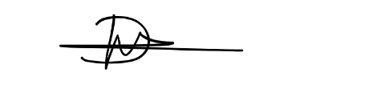
IT24103630 | SSRF, capture MailHog baseline request/response and fixed retest; locate URL validation/allowlist or destination-control fix; attach relevant scan evidence | 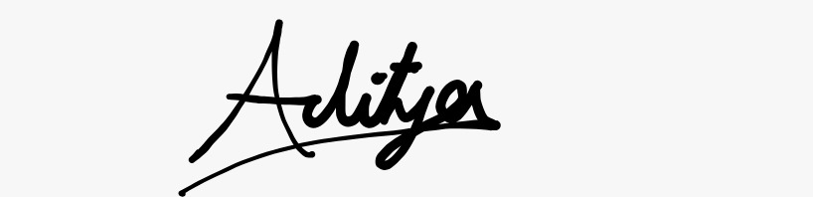
IT24103854 | BOLA/IDOR, capture cross-owner baseline and fixed retest plus authorized-owner control case; locate ownership check; attach relevant scan evidence. | 

Conclusion
This project demonstrated the integration of security practices into a DevSecOps software delivery lifecycle using OWASP crAPI. Four application vulnerabilities were analysed using STRIDE-based threat modelling and risk assessment, followed by controlled exploitation, source-code remediation and regression testing.
The final implementation integrates Semgrep, Trivy and Gitleaks into a GitHub Actions pipeline. The affected workshop service is built from the project source before container security scanning, ensuring that the scanned artifact corresponds to the reviewed application version.
The project also demonstrates secrets management through separation of credentials from source control and the use of protected CI/CD secret mechanisms. The industry case study demonstrates why security controls must cover source code, dependencies, secrets and build artifacts rather than relying on application testing alone.
Overall, the implementation demonstrates a practical DevSecOps feedback loop in which vulnerabilities are identified, security controls block unacceptable conditions, remediation is applied, and the resulting build is re-tested before being considered secure.

References
[1] Cybersecurity and Infrastructure Security Agency (CISA), “AA20-352A: Advanced Persistent Threat Compromise of Government Agencies, Critical Infrastructure, and Private Sector Organizations,” Dec. 2020. [Online]. Available: https://www.cisa.gov/news-events/cybersecurity-advisories/aa20-352a. Accessed: Sep. 28, 2026.
[2] Enduring Security Framework, “Securing the Software Supply Chain: Recommended Practices for Developers,” CISA/NSA, 2023. [Online]. Available: https://www.cisa.gov/sites/default/files/2023-12/ESF_SECURING_THE_SOFTWARE_SUPPLY_CHAIN_DEVELOPERS.pdf. Accessed: Sep. 28, 2026.
[3] OWASP Foundation, “OWASP crAPI.” [Online]. Available: https://owasp.org/projects/crapi. Accessed: Sep. 28, 2026.
[4] OWASP, “crAPI: Completely Ridiculous API,” source repository and project documentation. [Online]. Available: https://github.com/OWASP/crAPI. Accessed: Sep. 28, 2026.
[5] IE3142 DevOps Security, “Building and Securing a DevSecOps Pipeline,” Continuous Assessment assignment brief, 2026.

